Medlar-with-Wesham Town Council Monthly Meeting to be held on
Tuesday, 23rd September 2025
at 7.30 pm in the Committee Room, Wesham Community Centre.

AGENDA

APOLOGIES:

CODE OF CONDUCT AND STANDING ORDERS
Members are reminded of the standard of conduct they must adhere to during Town Council meetings.

DECLARATION OF INTERESTS:
Members are reminded that any direct or indirect pecuniary or other interests should be declared as required by the Council’s Code of Conduct for Members.

25/98 APPROVAL OF THE MINUTES
OF THE COUNCIL MEETING held on 15 July 2025. No meeting held during August 2025

25/99 MATTERS ARISING – any item not covered by agenda or action list

25/100 POLICING ISSUES -
- Crime Reports – Police.uk. Police commissioner contacted. MP A Snowdon has been copied in. Letter was handed in to the police station by the Town clerk. We now have PCSO’s appointed to the area and they have made contact.
- Policing Issues – to discuss any items raised by Councillors

25/101 PLANNING
25/0324 - Pennine View, Weeton Road - objection sent to planning officer on 08/08/25
25/0413 - Taylor Wimpey 250 dwellings on Weeton Road. Public Meeting to be held 10th September in the Community Centre - respond by 1st October
25/0535 - Mowbreck Hall Farm - Biodiversity Plan & condition 5 Habitat Mgmt (25/0188)

25/102 LICENSING LIST
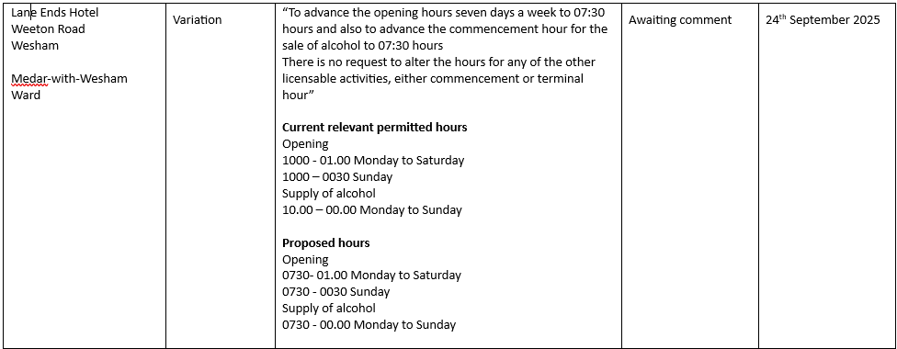
Responses by 25th September - response to say they had visited and posters had been put in the windows and the reason was to start serving breakfasts

25/103 PLAYING FIELDS and OPEN SPACES
- Open Spaces Contract - to discuss any issues raised by Councillors
- Fleetwood Road Playing Fields - to discuss any issues raised

- Kirkham Junior Football Club - SLA sent and returned signed - payment received

- Bollards and Fencing

- Guttering repairs on Pavilion

- Signage for Fleetwood Road car park – ordered and installed w/c 18/08/2025

- Doorstep Green, Derby Road - solar lighting update. – received warranty details etc from local company - Altitude Services
Damage to seesaw on in play area reported and now repaired. On going maintenance and review of slide apparatus in the play area
- Benches - Quote for 4 benches from Glasdon
- Hedges/Shrubbery - Hillcrest View corner of Derby and Wesham Hall Road corner of Derby Road - responsibility for hedge cutting ?

25/104 HIGHWAYS AND RAILWAYS –

Kirkham Town Council to keep Wesham Town Council informed of any news as it affects both Kirkham and Wesham.

Network Rail - signage for car park. Town Clerk has emailed Network Rail

Request for council to discuss possibility of designated disabled parking space outside
Coop on Weeton Road and outside hairdressers on Station Road - Town Clerk has contacted Highways 12/08/2025 Ref: 686291

25/105 GOVERNANCE, FINANCE AND INSURANCE
Finance meeting to be held to discuss accounts in detail.
Sum up accounts and transfer of funds

Accounts payable and income received report –

Accident and Incident Reporting

- Review Insurance Policy. Valuation Survey

25/106 HUMAN RESOURCES - to discuss any issues raised

25/107 WESHAM COMMUNITY CENTRE
Work commenced on hall and entrance decoration plus joinery work and decoration of the bar area. Community Centre Meeting to be arranged.
Bar bookings to Cllr E Bickerstaffe

25/108 PATH - SCOUT HUT TO SCHOOL
Awaiting response from C of E School. Bursar of Wesham C of E school contacting Diocese Architect. Received response from FBC.

25/109 WEBSITE – UPDATE
Councillors who have not yet done so will need to get devices ie phones, tablets, laptops set up with Councillor email address. Liaise with Easy Websites.
Do councillors require photos for the website page?

25/110 MAYORAL CHAIN AND REGALIA
Quotation for extra links and pendants. Cllr E Bickerstaffe has contacted company

25/111 - BOWLING CLUB
Respond to email regarding continuation of using the Community Centre Facilities.
Discuss quotes from T Ascroft Garden Services regarding restoration work on Bowling Green.

25/112 - ALLOTMENTS
Northern Trust - twice yearly payment

25/113 - REMEMBRANCE SUNDAY
Invitation from Kirkham Council for Mayor to attend.
Arrangements - Order wreaths, Procession, order of service, road closures -

25/114 - SLA MAINTENANCE OF PLAY AREAS

25/115 - ANNUAL/BI-ANNUAL MEDLAR WITH WESHAM NEWSLETTER

25/116 - NEXT COUNCIL MEETING DATE
TOWN CLERK ON HOLIDAY 21 OCTOBER - TRY FOR 22 OCTOBER

Ruth Ross Date: 10/09/2025

